Chapter 2: The Chemical Context of Life

This chapter covers the basics of what you may have learned in your chemistry class. The questions that follow should help you focus on the most important points.

Concept 2.1 Matter consists of chemical elements in pure form and in combinations called compounds

- Define and give an example of the following terms:
  - Matter

  - Element

  - Compound

- What four elements make up 96% of all living matter?

- What is the difference between an essential element and a trace element?
  - Trace element

  - Essential element

Concept 2.2 An elements properties depend on the structure of its atoms

- Sketch a model of an atom of helium, showing the electrons, protons, neutrons and atomic nucleus.

- What is the atomic number of helium? ___________ Its atomic mass? ____________

- Here are some more terms you should firmly grasp. Define each term.
  - Neutron

  - Proton

  - Electron

  - Atomic number

  - Atomic mass

  - Isotope

  - Electron shells

  - Energy

- Consider this entry in the periodic table for carbon.

  - What is the atomic mass? ________ atomic number? ________

  - How many electrons does carbon have? __________ Neutrons? __________

₆
C
¹²
- which is the only subatomic particle directly involved in the chemical reactions between atoms?

- What is potential energy?

- Explain which has more potential energy in each pair:
  - Boy at the top of a slide / boy at bottom of slide

  - Electron in first energy shell / electron in third energy shell

  - Water / glucose

- What determines the chemical behavior of an atom?

- Here is an electron distribution diagram for sodium:

  - How many valence electrons does it have? ____________

  - How many protons does it have? ___________

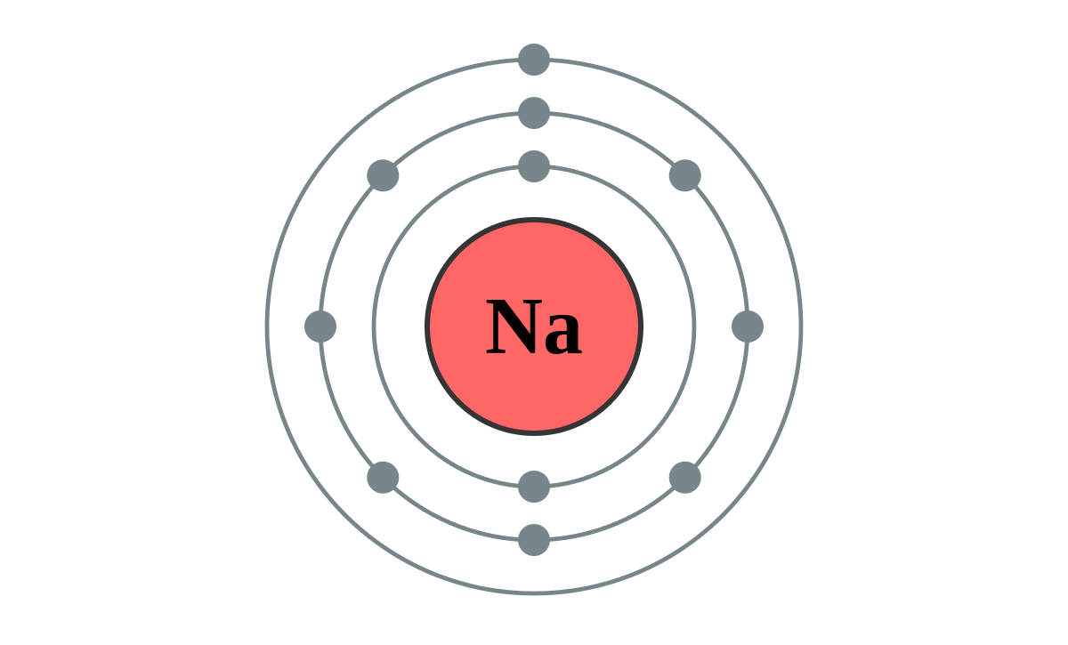

Concept 2.3 The formation and function of molecules depend on chemical bonding between atoms.

- Define molecule

- Now, refer back to your definition of a compound and fill in the following table:

 | Molecule? (y/n) | Compound? (y/n) | Molecular formula | Structural formula
Water
Carbon dioxide
Methane
Oxygen gas

- What type of bond is seen in O₂? Explain what this means.

- What is meant by electronegativity?

- Explain the difference between a nonpolar covalent bond and a polar covalent bond.

- Make an electron distribution diagram of water. Which element is most electronegative? Why is water considered a polar molecule? Label the regions that are more positive or more negative.

- Another bond type is the ionic bond. Explain what is happening in the figure below.

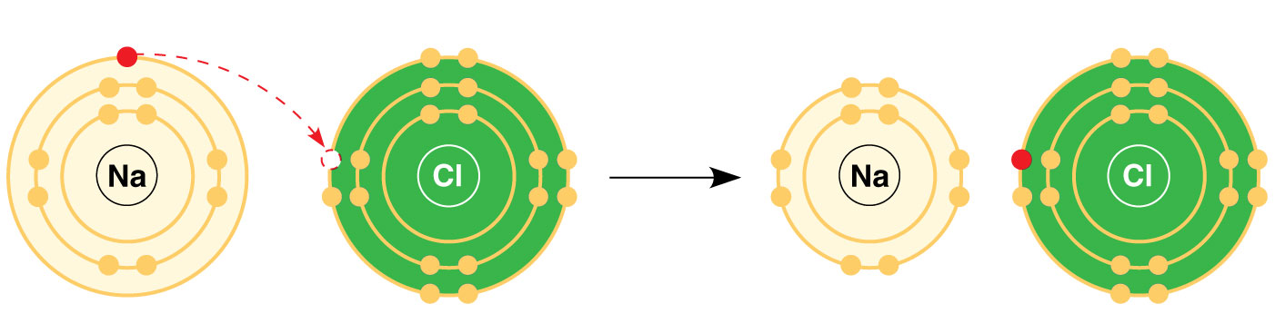

- What two elements are involved above?

- Define anion and cation. In the preceding example, which is the anion?

- What is a hydrogen bond?

- Explain van der Waals interactions. Though they represent very weak attractions, when these interactions are numerous they can stick a gecko to the ceiling!

- Here is a list of the types of bonds and interactions discussed in this section. Place them in order from strongest to weakest: hydrogen bonds, van der Waals interactions, covalent bonds, ionic bonds.

Strong

Weak

- Use morphine and endorphins as examples to explain why molecular shape is crucial in biology.

Concept 2.4 Chemical reactions make and break chemical bonds

- Write the chemical shorthand equation for photosynthesis. Label the reactants and the products.

- For the equation you just wrote, how many molecules of carbon dioxide are there? ________ How many molecules of glucose? _________ How many elements in glucose? ___________

- What is meant by dynamic equilibrium? Does this imply equal concentrations of each reactant and product?
Concept 2.5 Hydrogen bonding gives water properties that help make life possible on Earth

- Study the water molecules on the below. On the central molecule, label oxygen (O) and hydrogen (H).

- Add + and – signs to indicate the charged regions of each molecule. Then indicate the hydrogen bonds.

- How many hydrogen bonds can a single water molecule form?

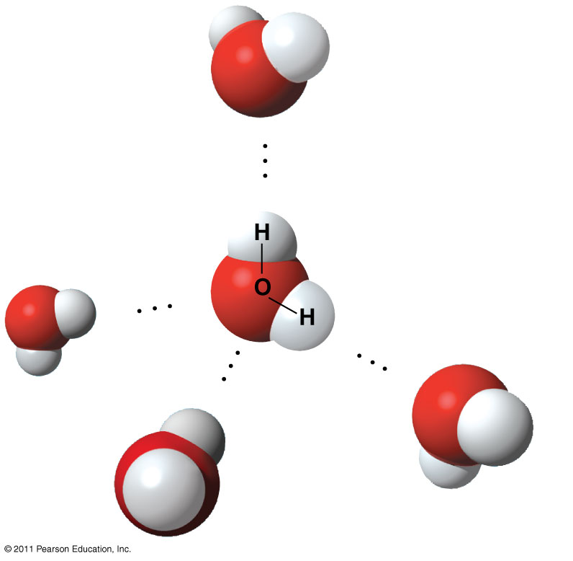

Hydrogen bonding accounts for the unique properties of water. Lets look at several.

Cohesion

- Distinguish between cohesion and adhesion.

- Explain how cohesion and adhesion both contribute to transpiration.

- What is demonstrated when you see beads of water on a waxed car hood?

- Which property explains the ability of a water strider to walk on water?
Moderation of temperature

- The calorie is a unit of heat. Define calorie.

- Water has a high specific heat. What does that mean? How does water’s specific heat compare to alcohols?

- Explain how hydrogen bonding contributes to water’s high specific heat.

- Summarize how water’s high specific heat contributes to moderation of temperature. How is this property important to life?

- Define evaporation. What is heat of vaporization? Explain at least three effects of this property on living organisms.

Expansion upon freezing

- Ice floats! So what? Consider what would happen if ponds and other bodies of water accumulated ice at the bottom. Describe why this property of water is important.

- Now explain why ice floats. Why is 4 degrees Celsius the critical temperature in this story?

Solvent of life

- Review and define these terms:
  - Solvent

  - Solute

  - Solution

- Explain why water is such a fine solvent.

- Define hydrophobic and hydrophilic.

- You already know that some materials, such as olive oil, will not dissolve in water. In fact, oil will float on top of water. Explain this property in terms of hydrogen bonding.

- Now, let’s do a little work that will enable you to prepare solutions. Read the section on solute concentration carefully, and show the calculations here for preparing a 1-molar solution of sucrose. Steps to help you do this follow. The first step is done for you. Fill in the rest.

Steps to prepare a solution:

  - Write the molecular formula. C₁₂H₂₂O₁₁

  - Use the periodic table to calculate the mass of each element. Multiply by the number of atoms of the element. (for example, O has a mass of 16 x 11 = 176 g/mole)

  - Add the masses of each element in the molecule.

  - Add this mass of the compound to water to bring it up to a volume of 1 Liter. This makes 1 Liter of a 1 molar solution.

- Prepare 1 Liter of a 0.5 molar glucose solution. Show your work.

- Define Molarity.

Acidic and basic conditions affect living organisms

- What two ions form when water dissociates?

- What is the shorthand way we represent the hydronium ion?

- What is the concentration of each ion in pure water at 25 degrees Celsius?

- pH is defined as the negative log of the hydrogen ion concentration. Look at the pH equation for neutral water:

pH = -log [10⁻⁷] = 7

What is the pH if the hydrogen ion concentration is 10⁻³?

- To go a step further, the product of H+ and OH- concentration is constant at 10⁻¹⁴.

[H+] [OH-] = 10⁻¹⁴

Water, which is neutral with a pH of 7, has an equal number of H+ and OH- ions. Now, define

Acid

Base

- Because the pH scale is logarithmic, each number change represents a 10X change in ion concentration.
  - So how many times more acid is a pH of 3 compared to a pH of 5?

  - How many times more basic is a pH of 12 compared to a pH of 8?

  - Explain the difference between a pH of 8 and a pH of 12 in terms of H+ concentration.

- A pH chart contains numbers from 1 to 14. Which numbers on the chart represent acidic, basic and neutral solutions?

- Even a slight change in pH is harmful! How do buffers moderate pH change?

- Exercise will result in the production of CO₂, which will acidify the blood. Explain the buffering system that minimizes blood pH changes.

- Discuss how CO₂ emissions affect marine life and ecosystems.

